Prashanth.S (19MID0020)

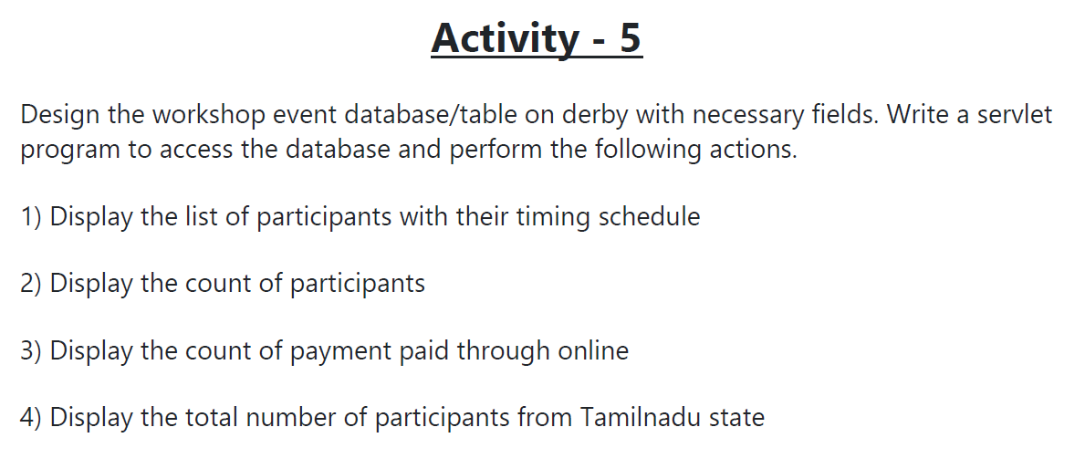

**Data-Base-file**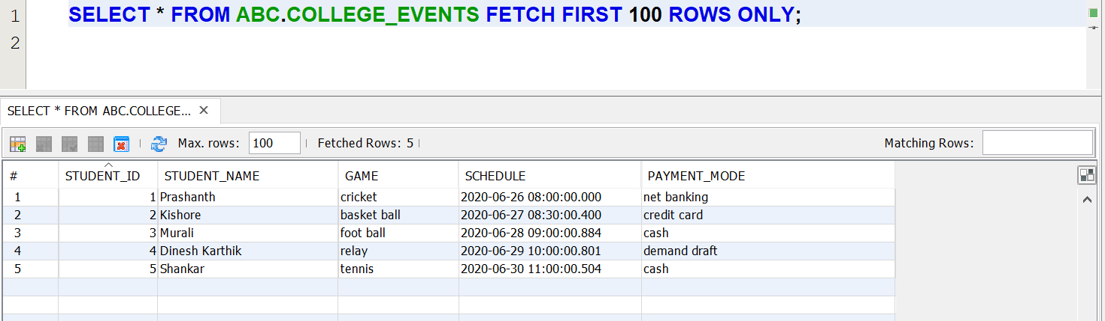

**Viewing the Data-Base**

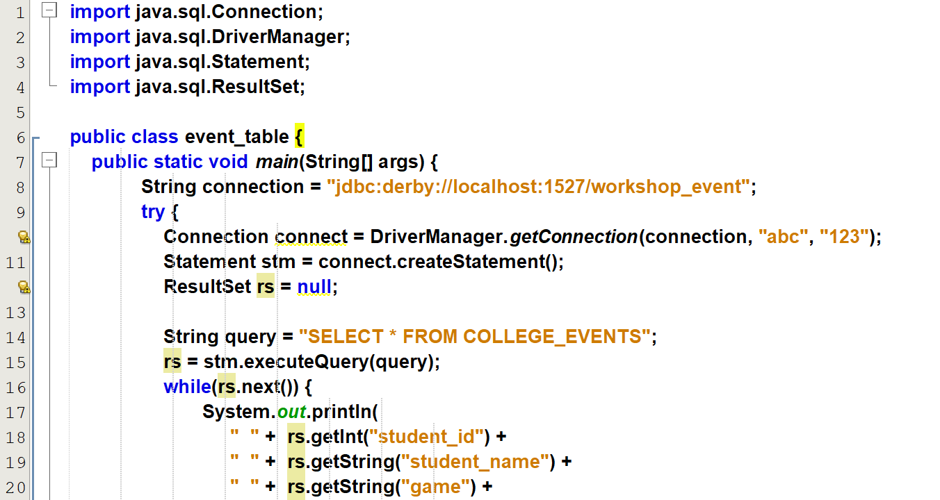

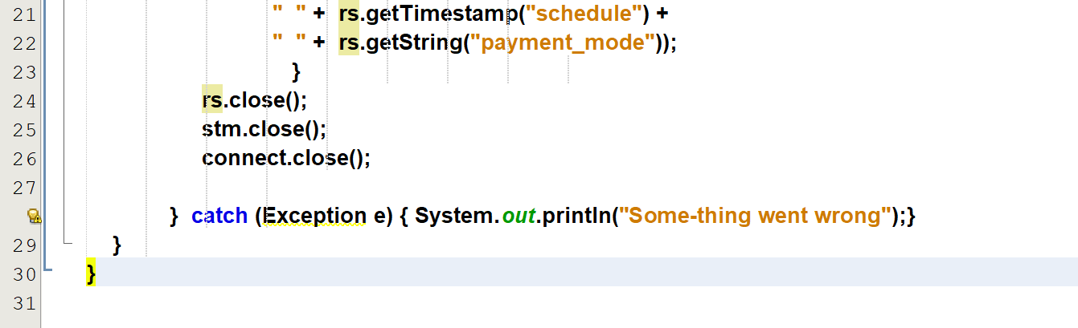

**Output**